SUMMER TRAINING REPORT
ON
TODO LIST APPLICATION
Submitted to Guru Gobind Singh Indraprastha University, Delhi (India) In partial fulfilment of requirement for the award of the degree of

BACHELOR OF TECHNOLOGY
in
COMPUTER SCIENCE AND ENGINERING
at
DELHI TECHNICAL CAMPUS, GREATER NOIDA
SUBMITTED BY
ADITYAN VERMA
07818002721
SEC – ‘B’
2023-24
SUBMITTED TO
MR. KAPIL KUMAR
(ASSISTANT PROFESSOR)

Department of Computer Science & Engineering
SESSION 2023
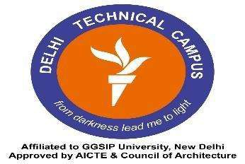

DELHI TECHNICAL CAMPUS, GREATER NOIDA
(Affiliated by Guru Gobind Singh Indraprastha University, New Delhi)

